GETTING HELP
If you are concerned that your child is being sexually exploited then there are people who can help
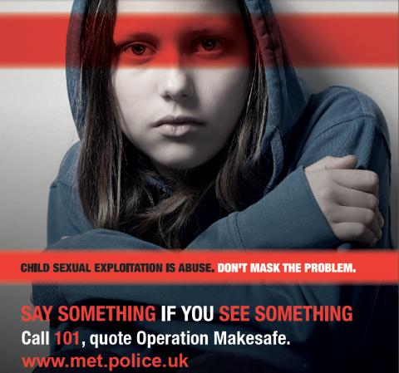

POLICE 999 or 101
The Police care about the safety of children and young people. If you think your child is in immediate danger then call 999 or you can report concerns by dialling 101.

CRIMESTOPPERS: www.crimestoppers-uk.org
Crimestoppers guarantees anonymity to all callers and website users. If you are concerned a young person is being sexually exploited, call or visit their webiste to provide information
CEOP: www.thinkuknow.co.ulk
CEOP provide lots of information about helping your children to stay safe on line. You can report online concerns to them
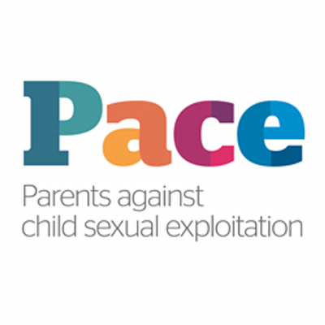 01132 405226
Offers a national support team who can talk to you about your immediate concerns, help you to assess the level of danger your child is in and signpost you to agencies in your area. They take calls during office hours

www.barnardos.org.uk For more information and research about child sexual exploitation and how it affects children and young people

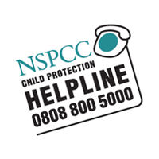
You can ring the NSPCC Helpdesk to report concerns and get advice if you are concerned your child is being exploited. They are available 24 hours a day

www.childrenssociety.org.uk
A national charity that runs local projects, helping children and young people when they are at their most vulnerable, and have nowhere left to turn.

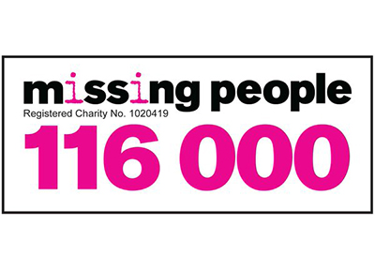
Missing People is the only charity in the UK which specialises in, and is dedicated to, bringing missing children and adults back together with their families

Information and resources which aim to raise awareness about child sexual abuse, answer questions and give adults the information, advice, support and facts they need to help protect children. https://www.parentsprotect.co.uk/
Internet Watch Foundation

www.iwf.org.uk
We work internationally to make the internet safer by removing images of child sexual abuse.

